
2025 Sunset Cruise Live Music Series
Seasonal Program Dates, Times, and Information

Experience a beautiful Gulf Coast sunset with panoramic views of Pensacola Bay with both covered interior and exterior seating, a climate-controlled cabin, and onboard restrooms. Sit back, relax, and enjoy some local talent and appetizers while meeting some new friends during this two-hour cruise and all for just $75.00!

A cash bar is also available!
Music Caterer/
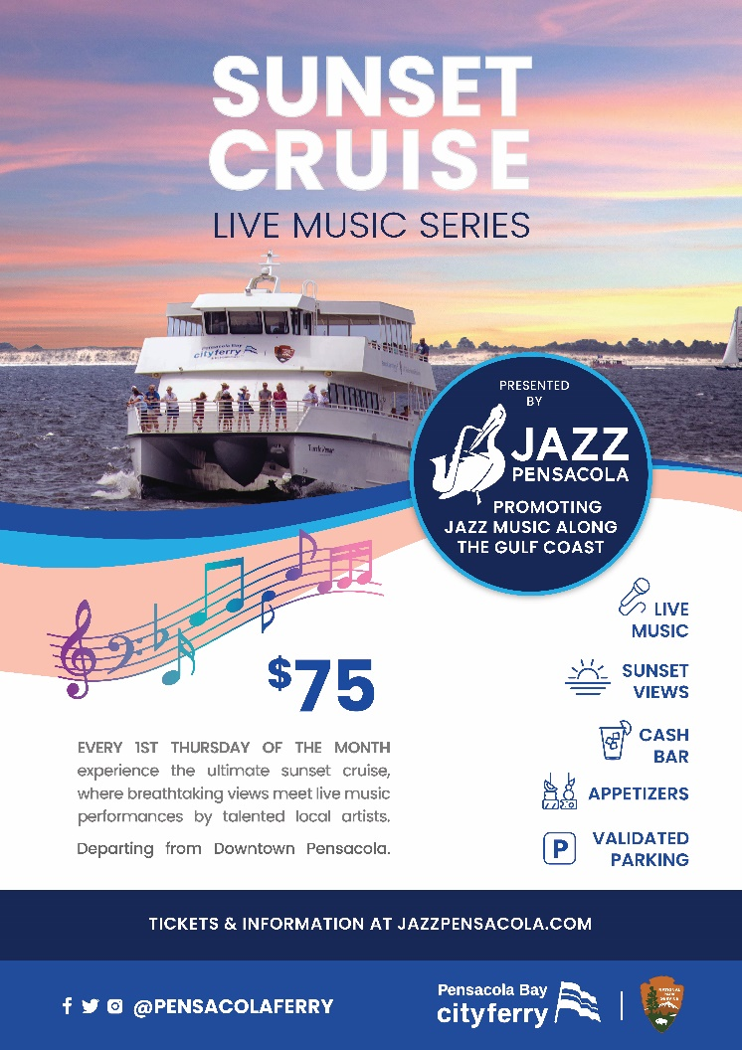
Date Theme Food Set-Up Depart Return
5/1 Smooth Jazz Appetizers 5:15pm 6:00pm 8:00pm
6/5 Acoustic Guitar Appetizers 5:45pm 6:30pm 8:30pm
7/3 Blues BBQ 5:45pm 6:30pm 8:30pm
8/7 Caribbean Vibes BBQ 5:45pm 6:30pm 8:30pm
9/4 Classic Jazz Appetizers 5:15pm 6:00pm 8:00pm
10/2 Smooth Jazz Appetizers 4:15pm 5:00pm 7:00pm

Cruise Overview: Know Before You Go!
- Cruise departs promptly from the downtown Ferry Landing at 750 S Commendencia Street.
- Parking is validated with your purchase.
- No refunds are provided unless the cruise is canceled by cruise operators due to weather or maintenance.
- Ferry is wheelchair accessible.
- DRESS is casual and comfortable for your sunset on the water, come aboard for a great time! It’s often cooler further from the land so we encourage an extra layer, a hat, and sunglasses!

NOTE:
No physical tickets will be given, your name will be checked from a proof of purchase list of names for parking and prior to boarding the Ferry.

